**NEWAR 2.0**

**Usage/Overview Guide**

**August 2022**

Jake Lorkin ([jake@lorkin.cc](mailto:jake@lorkin.cc))

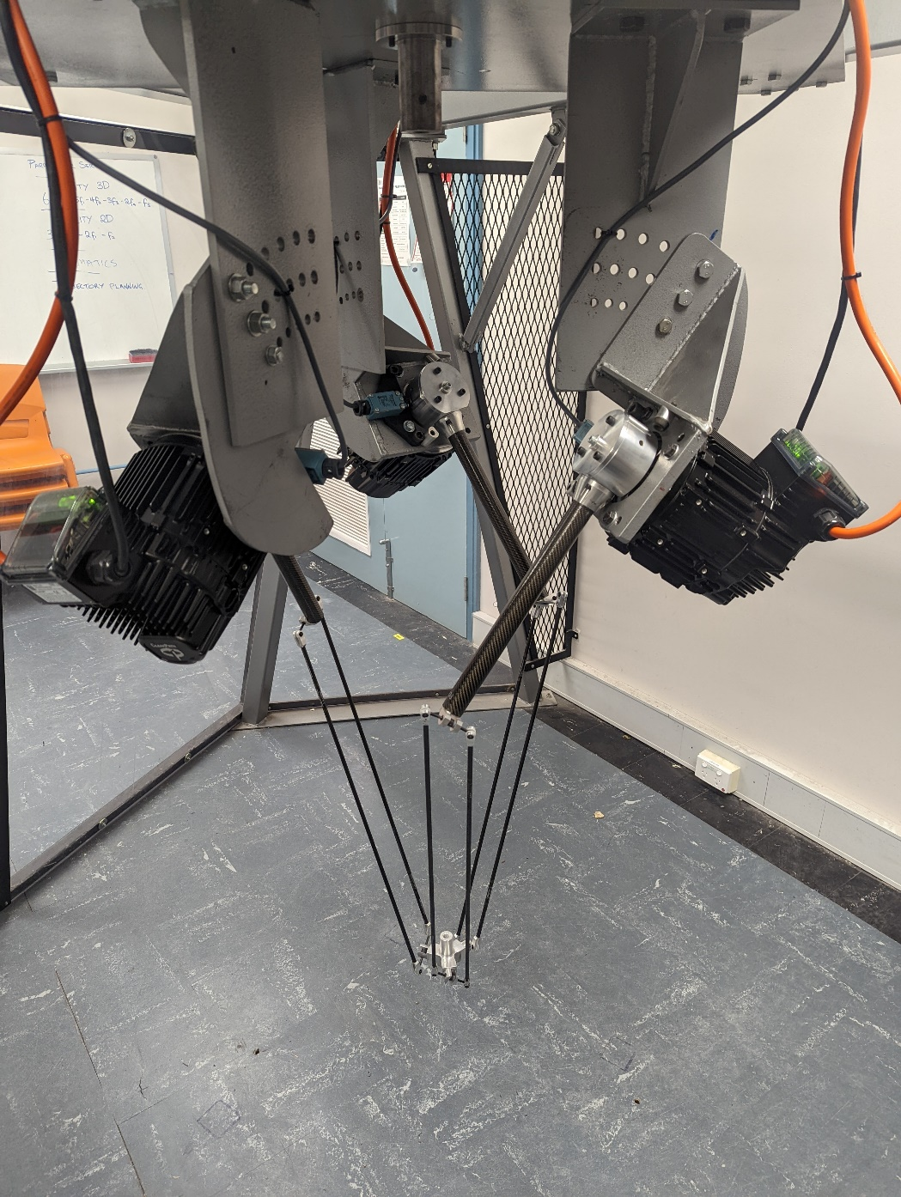

Lab Room Setup

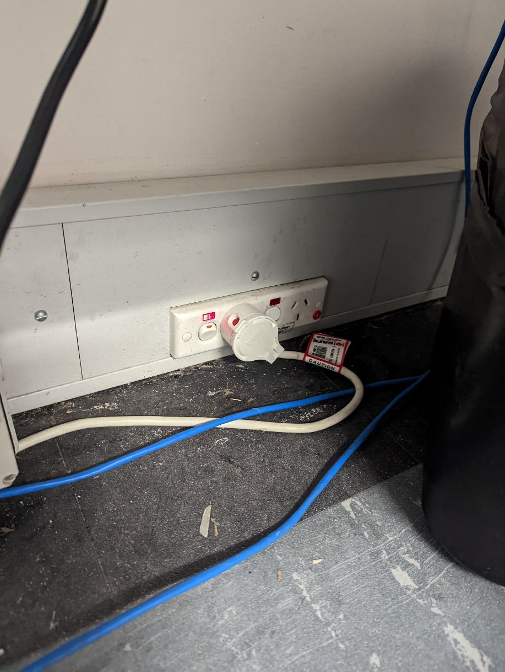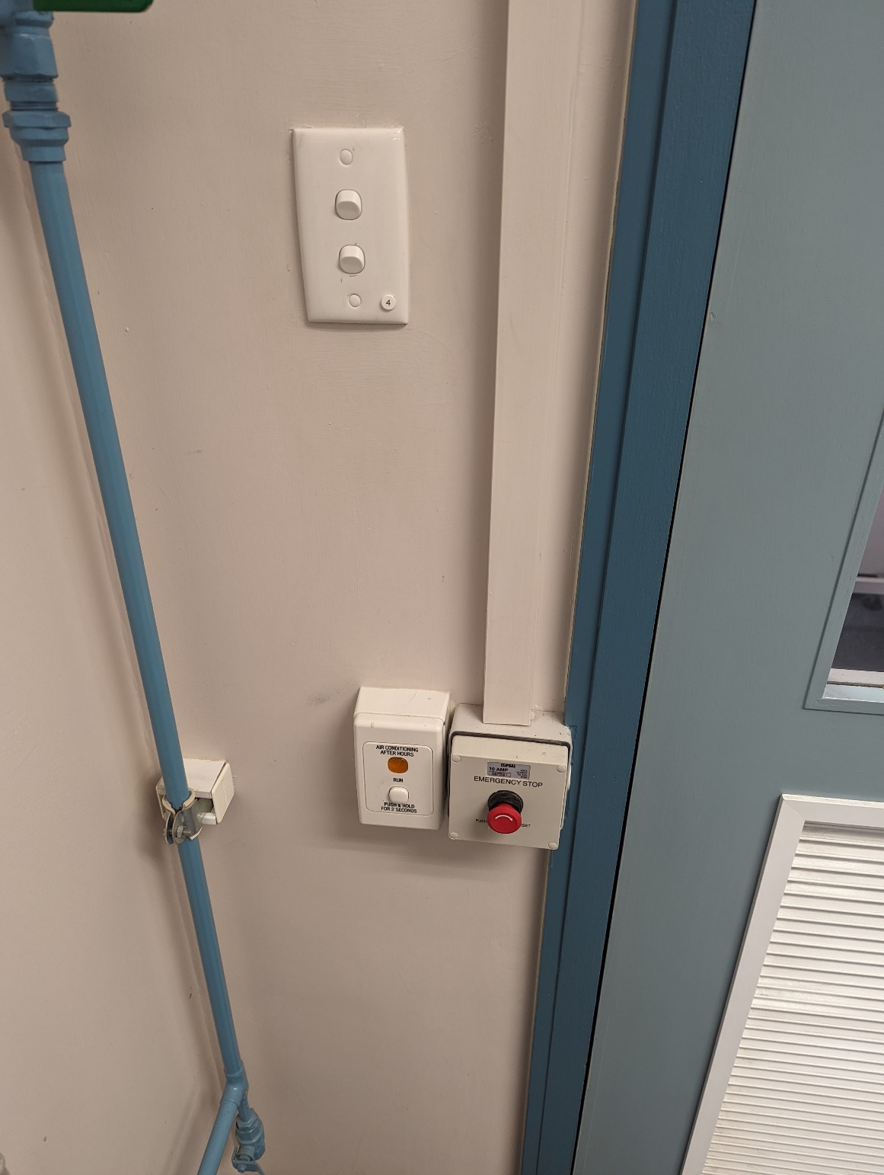

**POWER SWITCH**

Power board for computer and robot, ensure red light is on. Check room E-Stop if not.

**ELECTRICAL POWER CUT-OFF**

This button will cut power to whole lab in case of emergency, ensure button is clear and accessible.

Make sure button is open by twisting it so room has power.

**AIRCON**

**LIGHTS**

Robot Setup

* 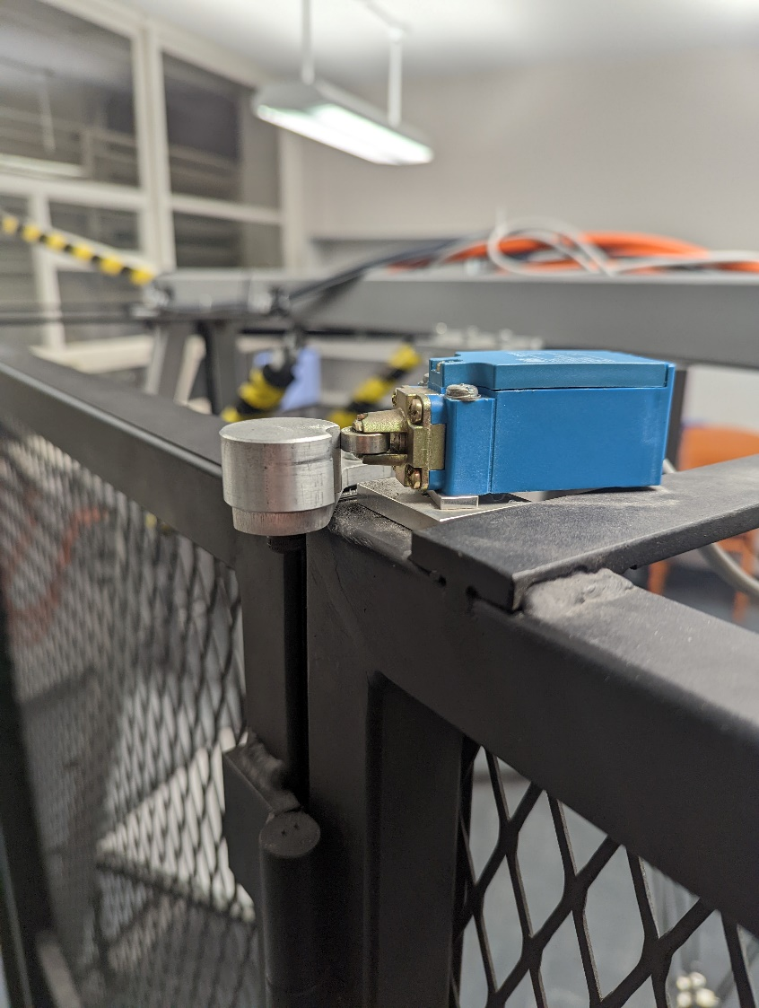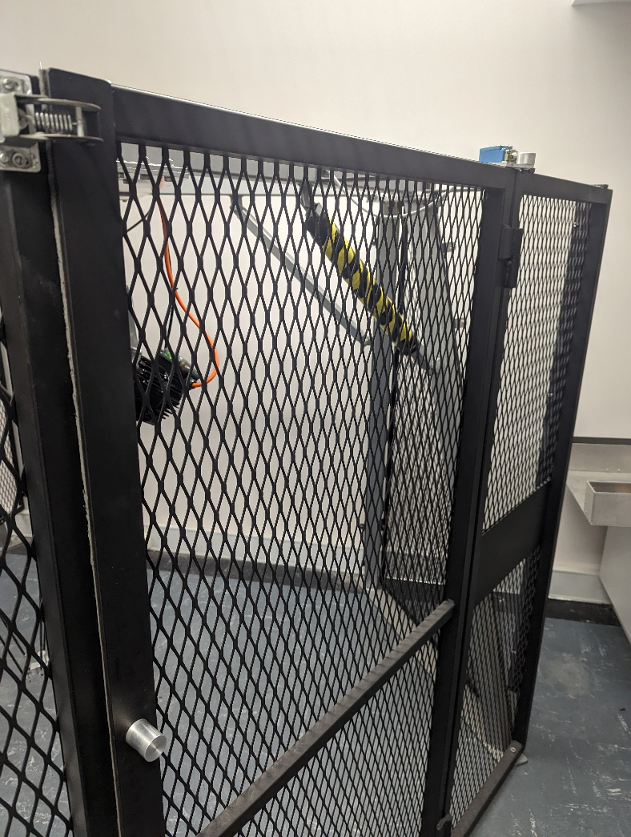Close cage door, check door limit switch is properly closed.

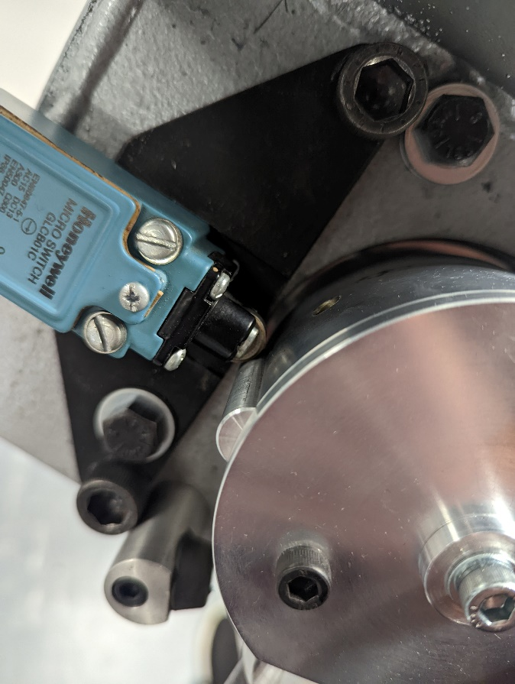

* Check all 3 motor limit switches are in this position.
* The switch should ‘click’ when the motor moves to its end positions.
* Bump in motor coupler should be below limit switch roller.

**Bump**

**Roller**

Robot Setup

* Check nothing is obstructing robots’ range of movement, and cage area is clear.

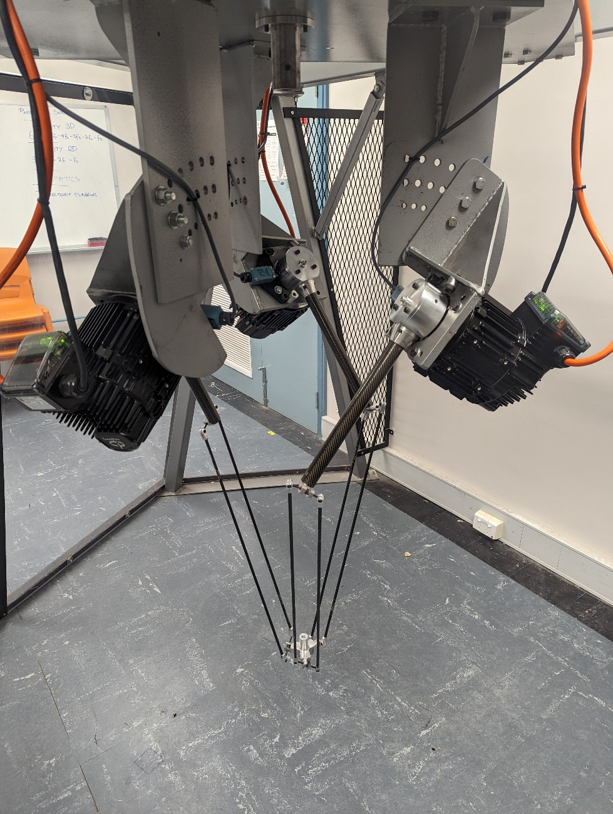

Power On

* Turn on motors by flicking motor power circuit breaker.
* Motors will energise and green LED’s should be visible on each motor.
* Otherwise check control box is plugged in and has power from the wall.

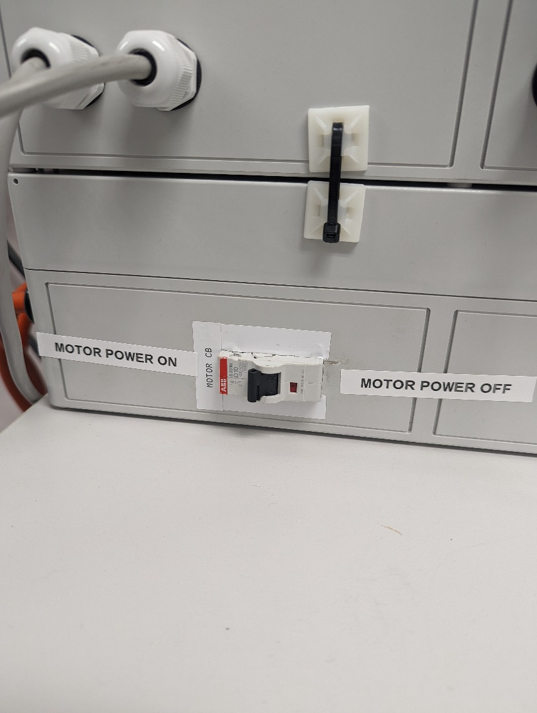

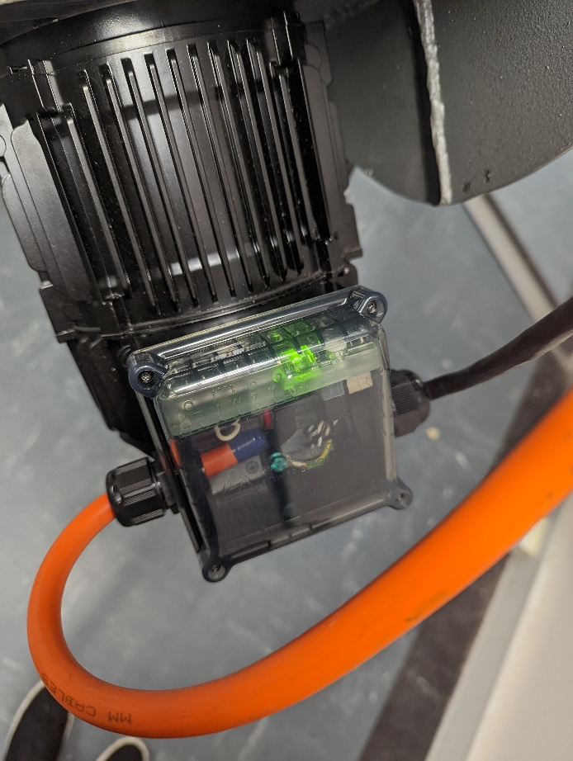

**Motor Power Circuit Breaker**

**Motor Power Indicator LED**

Power On

* 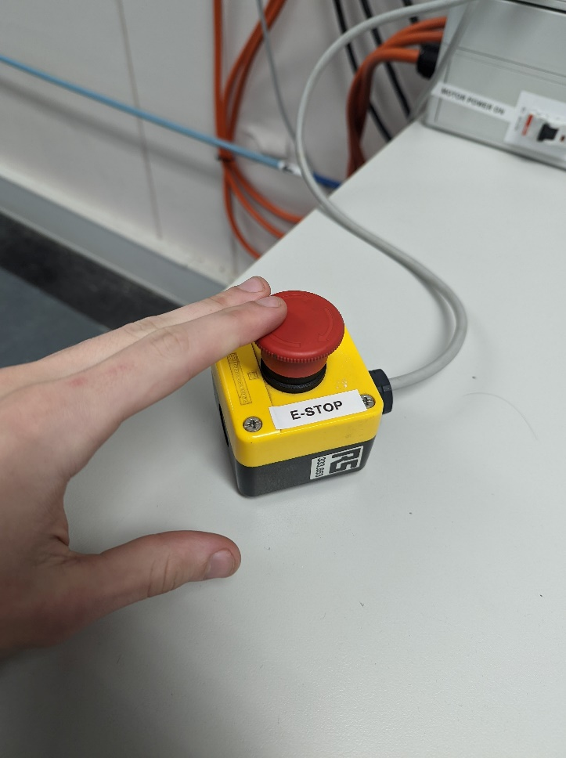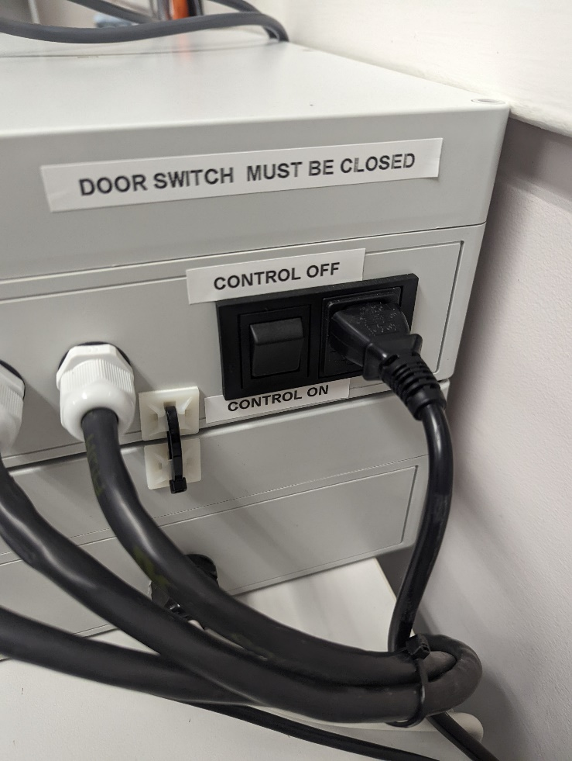Power on Control Box switch. Check control box e-stop is open.

**Control E-Stop**

Disables motor movement, motors will also be disabled if cage door is opened.

* 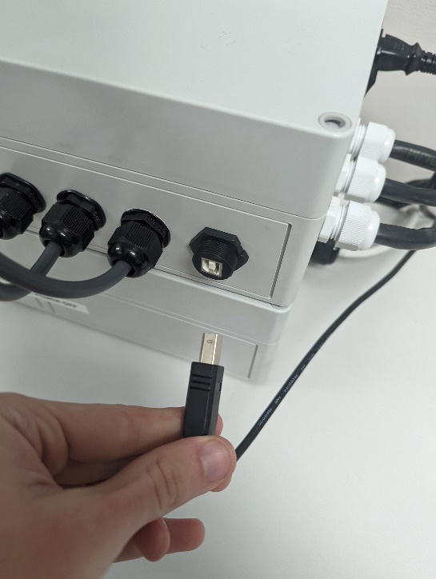Make sure control box is plugged into computer’s USB port.
* Teknic ClearPath SC Hub should be visible on device manager.
* If not check all power connections and switches.
* Ensure door switch is closed and E-Stop open.

Start Program - Basic

* Log into lab PC with staff or student account.
* All NEWAR files are saved locally under

**C:\Users\Public\NEWAR Parallel Robot**

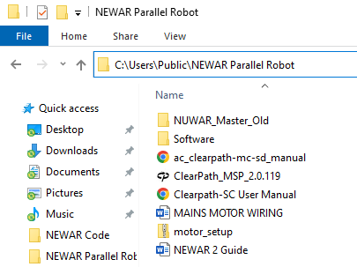

* 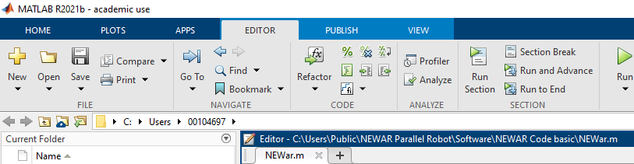Run MATLAB and using the “Open” button open “NEWar.m”
* This line opens a ‘.coords’ file that contains XYZ, coordinates and speed/acceleration info for the robot to follow



Start Program - Basic

* A ‘.coords’ file is a csv file that follows the structure

(X coord), (Y coord), (Z coord), (accel)*, (vel)*, (delay)*

* 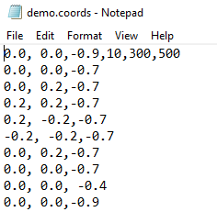* - means optional and all speed values are in RPM/s, delay is in milliseconds and coords in meters with the steel pole at the top being the origin.
* Delay is the minimum time a move will take, so once a move is done the remaining time will be waiting.
* optional parameters carry over onto previous lines until overwritten.
* Save your coordinate file and run the MATLAB program.

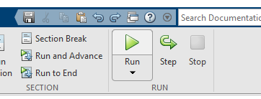

* Motors should home, make a few clicking noises and then start the program.

Max Values:

* Motor Acceleration: 2000 RPM/s/s
* Motor Velocity: 500 RPM/s
* X: (0.7, -0.7). Y: (0.7, -0.7). Z: (-0.4, -0.7)